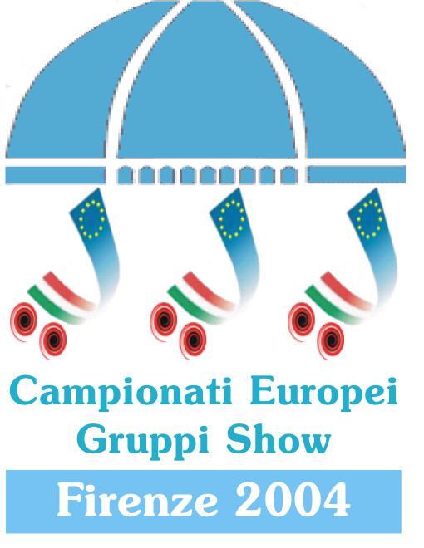
The Organization
FIORENTINA PATTINAGGIO
C/o Sozzi
Via Villani, 42
50124 Firenze - Italy
Tel.+39/055/2207066
Fax + 39/055/221746
E-mail info@artisticworldcup.org
To All European Federations

To CEPA European Committee

Florence, 15/02/2004

Subject: European Championship for Precision and Show Teams 2004

As host for the 2004 European Championship for Precision and Show Teams we hereby would like to give you all organizing information.

- DATE/PROGRAMME
29 April 2004 – Training
30 April 2004 – Training / Opening Ceremony / Competitions
01 May 2004 – Competitions / Closing Ceremony

- ORGANIZER:
FIORENTINA PATTINAGGIO
C/o Sozzi
Via Villani, 42
50124 Firenze - Italy
Tel.+39/055/2207066
Fax + 39/055/221746
E-mail info@artisticworldcup.org

- THE EVENT WILL TAKE PLACE IN:
Palazzo dello Sport
Viale Paoli
Firenze
The nearest exit by highway (A1) is “FIRENZE SUD”, then you have to follow the direction (road sign) “STADIO”.
The “Palazzo dello Sport” is in front of “Stadio” (Football Stadium of Florence).
Important!!! People coming from out of Florence with Tourist Bus (example, Clubs who arrive to Bologna Airport and arrive to Florence with Bus) must ask for a pass in order to avoid the payment of a compulsory tax.
The request of this pass should be sent by fax to Mrs. Cristina.
The request, made to the kind attention of Mrs. Cristina, must include the number plate of the Bus and the name/address of the company where you have rent the Bus.
Fax +39/055/363237 – Tel.+39/055/363362

- RINK
25 x 50 meters – Cement and quartz with on Roll-On.
Capacity of the “Palazzo dello Sport” 6500 seats.
Will be used on the rink only normal white light during the Training/Competitions.

- ROOM RESERVATION & BUS RENT
In the period of European is difficult to book Hotels in Florence because the event is in concomitance with the popular week-end of 1st of May.
The following agency (Official Agency of these Europeans) have already reserved a lot of rooms for the Club at a very convenient price.
Booking with the agency means that you will also have the following benefits:
- Assistance for free Bus Pass
- Special price entry tickets
- Tourist information on the city, organized visits to the city, visits to the Museums.
Send all requests using the attached form to:
Hevento SRL
Mrs. Morena Gallorini
Tel. +39/055/7131700
Fax +39/055/7135335
e-mail m.gallorini@hevento.com

Cost Min/Max per person, per each night, per Hotel category:
 | Double Room | Triple Room | Quadruple Room
2 Stars | MIN. Euro 45,00  MAX. Euro 65,00 | MIN. Euro 40,00  MAX. Euro 68,00
3 Stars | MIN. Euro 45,00  MAX. Euro 84,00 | MIN. Euro 47,00  MAX. Euro 65,00
4 Stars | MIN. Euro 71,00  MAX. Euro 90,00 | MIN. Euro 57,00  MAX. Euro 68,00

In order to have a four (4) bed room you have to tell it to the Agency when you make reservation of the rooms.

There is possibility to rent bus, please contact the Agency aforesaid.

- TRANSPORT:
As required by CEPA Rules 2004 transport for Judges/Calculators/Cepa will be assured from Hotel to Rink and Vice versa.
Transport of Skaters/Club is in charge of Each Club.

- FOOD:
Inside “Palazzo dello Sport” it will be possible to have lunch and dinner, and the restaurant will make two menu, one international and one typical Florentine, with price around 9-13 Euro.
In next communication more details about menu and price.
- FILMING by VIDEO:
Using Video camera is possible, you will need to obtain a Video accreditation. You can buy this accreditation at the moment of the normal accreditation to the event.
The cost of Video Accreditation will be communicate in next communication.

- INSCRIPTIONS:
All official inscriptions, like Cepa Book prescribed, must arrive by Federation.
Send the attached document (please write in Capital or by computer, please all data very clear) before 15th of March to:

1) First copy to Organizer (preferably through e-mail):
Inscription Form to:
info@artisticworldcup.org
Fiorentina Pattinaggio
C/o Sozzi
Via Villani, 42
50124 Firenze
Italy

IMPORTANT!!!!
Together with the registration you must send the photos of the skaters/Delegate/Trainer for the pass.
Remember that you can make accreditation for:
1 delegate per team
1 trainer per team
2 Bus Drivers
1 extra pass each 10 skaters for extra people helping in dressing room (e.g. 32 skaters, will be given three (3) extra pass).

2) Second copy to Cepa President (preferably through e-mail):
Inscription Form to:
m.brooks@tiscali.it
Margaret Brooks
“Villa Ruscelli”
Contrada Ferrini 22
63022 Falerone AP
Italy

3) Third copy to Italian Cepa Member (preferably through e-mail):
Inscription Form to:
faggioli.m@virgilio.it
Marco Faggioli
Via Roberto Preti 111/H
40059 Medicina BO
Italy

We would like to inform you that on web site www.artisticworldcup.org and www.fihp.org you will find details and information

With Friendly Regards

Cristina Sozzi

